**Training on Drone Image Processing and Analysis for Glacier Monitoring**

**Practical -2: Glacier Velocity Estimation Using Radar Image (Sentinel-1)**

***Learning Outcomes***

* How to estimate the glacier velocity using ESA SNAP open-source software
* How to install/use ESA SNAP open-source software.
* How to download Sentinel-1 Datasets.

***Background***

Glacier velocity refers to the movement speed at which a glacier moves, flows over time. Measuring the behaviors of glacial flow rate is always a typical aspect of glacier monitoring. The glacier velocity is applicable to optical, radar and even UAV imagery. In this practice, we will focus on how to conduct glacier velocity estimation using Sentinel-1 radar data and open-source software for SAR imagery, ESA SNAP.

Typically, the glacier velocity is estimated between two different times of image acquisition to the same area, preferably a year time extent between two images.

***Prerequisites***

1. Download two SAR images of a desired area to evaluate.
   1. Alaska Satellite Facility (<https://search.asf.alaska.edu/#/>). Registration required.
   2. Copernicus Dataspace Browser (<https://browser.dataspace.copernicus.eu/>). Registration required.
2. Download the installer file of ESA SNAP software: <https://step.esa.int/main/download/snap-download/>

For the training, all the installer files and two SAR images are provided in the shared folder.

***Materials used for practical***

* Two Sentinel-1 SAR images.
  + S1A_IW_GRDH_1SDV_20160207T235426_20160207T235455_009847_00E6BD_6A66.zip
  + S1A_IW_GRDH_1SDV_20161028T235438_20161028T235507_013697_015F8B_A337.zip
* ESA SNAP Installer: esa-snap_all_windows-11.0.0.exe

***Important System Requirements***

Many of the steps require some time to process. We recommend the following:

* At least 16 GB of RAM memory
* Close other applications if possible while using SNAP software
* Do not use the computer during processing to avoid crashes.

***Step 1: Install ESA SNAP v11.***

After the progress bar is completed to initialize, a welcoming page appears. Click on Next.

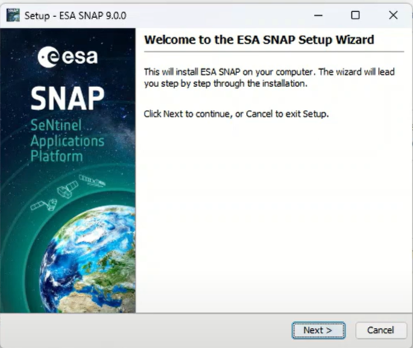

Accept license agreement and click on next.

Proceed with the recommended section.

Keep your software path in C drive.

Select all the toolboxes in include in the software.

After the installation, finish the installation wizard. And click on ESA SNAP icon on desktop. The following platform will appear. You’re ready to use ESA SNAP capabilities.

WorldView

Product Explorer

**Step 2: Upload the two S2 images by dragging them into Product Explorer.**

The geographic extend of the products can be visualized in the WorldView.

The details of the products can be checked within this folder structure.

You can expand the **product folder**, investigate the **bands folder**. You will notice that there are four types of bands available. Note that S1 dataset provides intensity band (strength of radar backscattered signal) and amplitude band (strength of radar’s signal strength). You will also notice that there are two subfixes “VV and VH” which represents two polarization types that SAR backscatter returns.

Double-click on one of the bands to visualize.

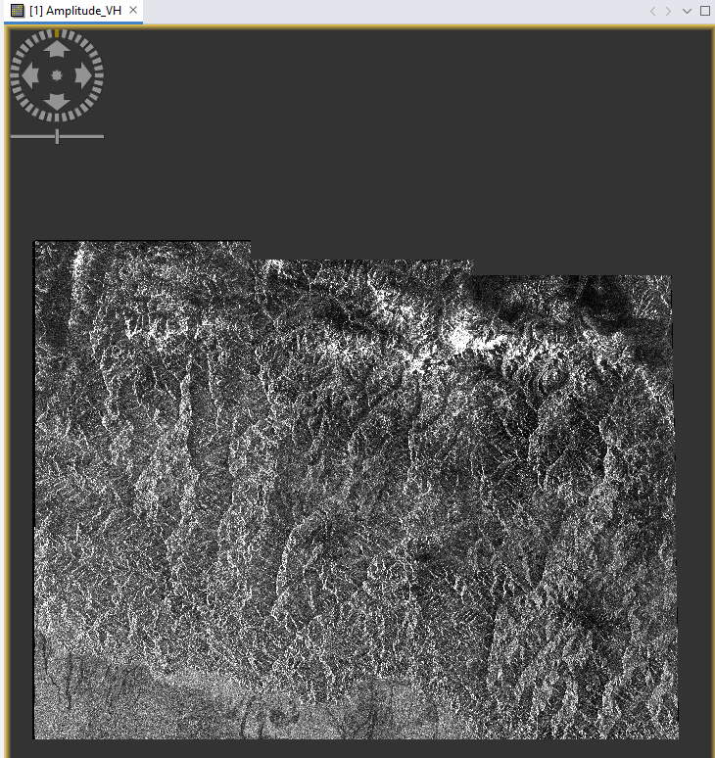

Notice that the band image is not geocoded i.e., the image is not properly oriented based on geographic coordinates.

***Step 3: Preprocessing the two SAR images.***

Preprocessing of the SAR images comprises:

1. Noise Removal
2. Radiometric Calibration

These functions are designated for Sentinel 1 Level -1 SLC products, GRD products which are not corrected.

First, we will apply **S1 Thermal Noise Removal** function.

1. Go Radar>> Radiometric >> S-1 Thermal Noise Removal
2. In I/O Parameters, select your S1 data product.
3. In Processing Parameters, select both polarizations, select **Remove Thermal Noise.**
4. Provide the output file path in I/O Parameters.
5. Click Run.

After completion, the thermal noise corrected output file is obtained. Try applying the same function to another S1 scene.

Next, we will apply the calibration.

1. Go Radar>> Radiometric >> Calibration
2. In I/O Parameters, select your S1 data product.
3. In Processing Parameters, select both polarizations, select **sigma0 band.**
4. Provide the output file path in I/O Parameters.
5. Click Run.

After completion, the calibrated output file is obtained. Try applying the same function to another S1 scene.

Once completed at this stage, you’ve calibrated and corrected S2 images.

***Step 3: Apply DEM-assisted Coregistration***

Now that all S1 images are calibrated, we now co-register these products to geocode using the orbits of the products and Digital Elevation Model.

1. Go Radar>> Coregistration >> DEM-Assisted Coregistration >> DEM-Assisted Coregistration
2. In Product-Set Reader, select your two calibrated S1 data products.
3. In DEM-Assisted-Coregistration, select your DEM of your desire to geocode. Keep the rest of the settings default.
4. Provide the output file path in Write.
5. Click Run.

***Step 4: Subset the data product***

The product obtained after DEM-assisted coregistration is too big in terms of file size for the computation to execute glacial velocity estimation. Thus, we’re subsetting the part of the swath acquired area to reduce file size.

1. Select the coregistered S1 data product in Product Reader.
2. Go Raster>> Subset
3. In Spatial-Product, Click on Use Preview. Draw a small boundary on the image preview where the glaciers are located.
4. In Band Subset, select VV band.
5. Keep the rest of the settings as default.
6. Click Ok.

A subset area was generated from the original dataset. We’re using this to calculate glacier velocity now.

***Step 5: Calculate the glacial velocity***

Now, we’re calculating the glacial velocity.

1. Go Radar>> SAR Applications >> Offset Tracking
2. In I/O Parameter, select the subset S1 data product.
3. In Processing Parameters, set Grid Azimuth and Range Spacing to 60. If you have prior knowledge of glacier velocity, you can change the maximum value of velocity to your desired setting. For now, we set as default.
4. Keep the rest of the settings as default.
5. Click Run.

Note that this will take time, depending on the computer and the area. Once completed, you can see the velocity product, by visualizing the velocity band in the band folder under the Product-Reader section.

From the visualization, we can see some parts have glacier movements of 0.3 m/yr (highlighted in red areas). Note that the product is not georeferenced yet. We are now doing in the final step.

***Step 6: Apply terrain calibration to your map.***

Remember that the area selected is quite mountainous. SAR images are sensitive to geometry and the aspect of the underlying ground which affects on you SAR image. We’re terrain correcting the velocity image.

1. Go Radar>> Terrain Correction >> Range-Doppler Terrain Correction.
2. In I/O Parameter, select the velocity product.
3. In Processing Parameters,
   1. Select the velocity band.
   2. For DEM, select SRTM 3-arc second.
   3. Select your pixel resolution to 10 meters.
   4. For output band, include DEM, in addition to velocity band.
4. Keep the rest of the settings as default.
5. Click Run.

Now, it’s time to export the data as GeoTiff file.

***Step 7: Export the data as GeoTiff File***

With SNAP, you can export any image files into different georeferenced images of your desired coordinate reference system (CRS).

1. Go File>> Export >>GeoTIFF.
2. Change the file path to save the output.
3. (Optional) If you want to change the filename in case it’s wrong,
4. Click Export Product.

Once completed, you can visualize the results in QGIS.

*Reference*  
<https://www.antarcticglaciers.org/glaciers-and-climate/observing-and-monitoring-glaciers-and-ice-sheets/measuring-glacier-velocity/>

<https://asf.alaska.edu/wp-content/uploads/2019/02/glacier_velocity_v1-1.pdf>